//TABLE CREATION

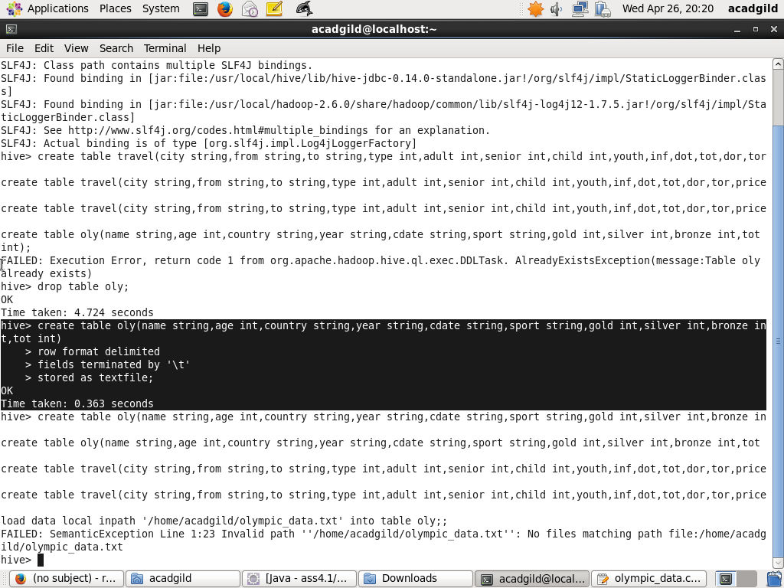

//DATA LOAD

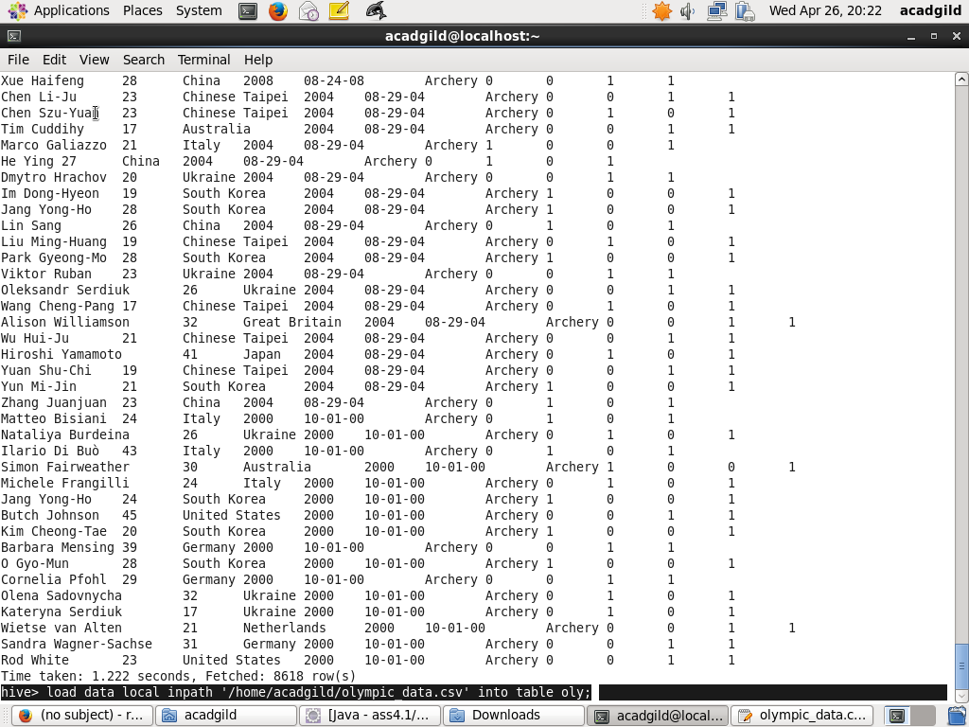

1. Write a Hive program to find the number of medals won by each country in swimming.

//QUERY EXECUTION

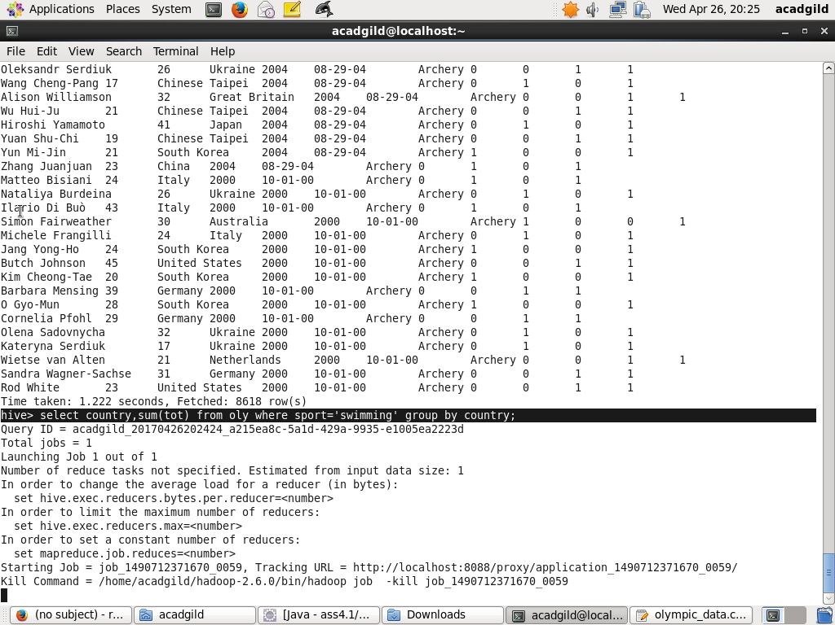

//RESULT

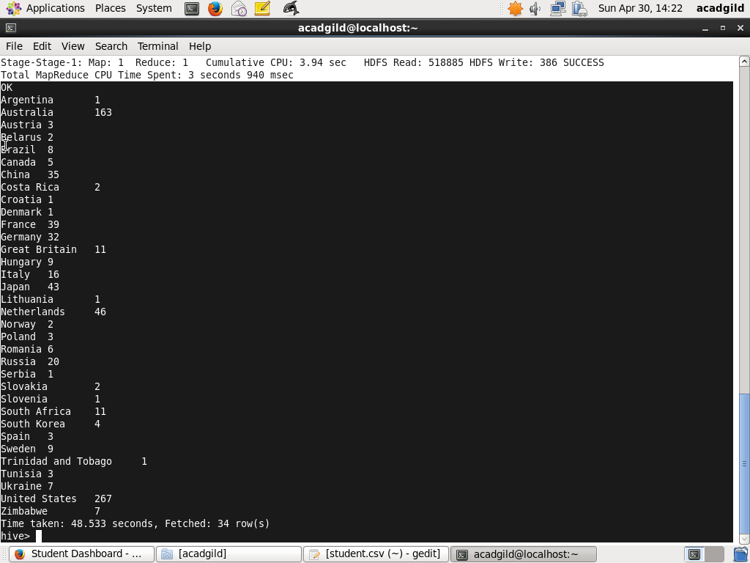

1. Write a Hive program to find the number of medals that India won year wise.

//QUERY EXECUTION

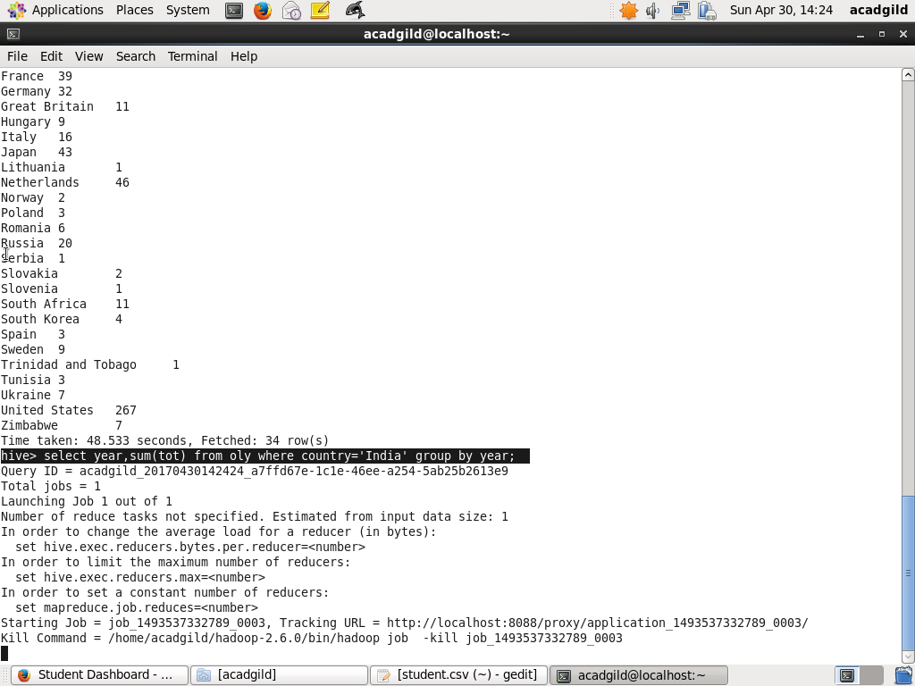

//RESULT

